Credit Risks in Daily Lives
Yijia Mao
Faculty Advisor: David Aldous
Jul. 13, 2014

According to Investopedia, credit risk is the risk of loss of principal or a financial reward stemming from a borrower’s failure to repay a loan or meet a contractual obligation. Credit risk arises whenever a borrower is expected to pay current debt but fails to. As a result, the investors or lenders will not be able to receive any interest payments or even lose the original principal. Here are some examples of credit risks: the consumers fail to repay the debt every month they borrow on their credit cards; the households fail to pay the designated amount every month or year for their mortgage loans; the corporations fail to pay back the principal and interest of the bonds they issue to investors. In this paper, I will explore the formation (reason) of credit risk in various situations and what actions the investors (banks and individuals) would take to mitigate the risk.

Part 1: Financial institutions (Banks) vs. Borrowers (Customers)

Before analyzing how financial institutions reduce credit risks, let’s explain how banks and other financial institutions determine whether to grant credit or not; if so, then how much credit would they provide to the applicants. Such credit granting process is necessary when the banks make decisions about issuing credit cards to customers. When lending out mortgage loans, the banks also take the customers’ credit record into account and then determine the reasonable amount of the loan.
Credit Scoring System
Credit Scoring is used in most forms of consumer lending, such as, credit cards, personal loans, insurance policies, etc. Banks use the customers’ credit scores to evaluate potential risks of lending and to mitigate losses due to default. The most common credit scoring used by lenders is FICO score, which can range from 300 to 850. The three major credit reporting agencies: Experian, TransUnion, and Equifax, produce three FICO scores. The FICO scores are included in an individual consumer credit report.
Besides FICO, various scholars have also examined and suggested a variety of credit scoring methods to help the banks forecast financial risk of lending individual loans. Lyn C. Thomas is one of the scholars that are dedicated to analyzing credit risk. In 2008, he added that although credit scoring is a well-established industry of modeling individual loans’ risks, models to evaluate credit risks of portfolios of consumer loans can be created through analogies to corporate loans. He explained that corporate credit risk models split into structural and reduced form modeling; similarly, he constructed consumer structural model based on reputation and affordability, which he explained in Structural Models in Consumer Credit published in 2007, and consumer reduced form models based on hazard functions and Markov chains. In this journal, the authors proved that the structural model has added important predictive power to traditional behavioral scoring approach. Andrade and Thomas, proposed this model for consumer lending using option theory and the concept of value of the consumer’s reputation. Both authors also compared a number of alternative models using Brazilian empirical data and a credit bureau score as proxy for credit worthiness. They constructed a more complex model for individual’s creditworthiness based on Merton Model or jump-diffusion processes (Zhou, 1997):
where dQt is the variation of creditworthiness in period t; μ is the drift parameter; σ is a volatility parameter; Wt is a standard Brownian motion; At is the jump amplitude in period t, where At is a i.i.d. variable with a normal distribution; dYt is a Poisson process with intensity λ, and dWt, dYt and At are mutually independent. They also suggest using a zero-inflated process for dQt, as is shown in the following equation:
where C1 is a random term that follows a Bernoulli distribution with probability Pc.
Andrade and Thomas tested all models derived from these two equations with the empirical data acquired from monthly observations of Credit Bureau scores by Serasa for the Brazilian market from January 2000 to January 2003 of 1000 consumers. Eventually, a zero drift diffusion model is proposed:
where P(t) is the probability of default within the time horizon t; K is the default threshold; S0 is the current score of the consumer; σ is the standard deviation of the consumer’s score; Φ(.) is the cumulative standard normal distribution function. This model has the best performance in modeling.
Besides Lyn C. Thomas’s, three Taiwanese scholars suggested a Bayesian latent variable model for behavior scoring with classification and regression tree (CART) approach for credit scoring in 2012. This model can help banks predict applicants’ future performance, determine the optimal credit limit and APR, and improve the banks’ efficiency.
The Bayesian behavior scoring model can be written as follows:
where yij denotes the credit rating of ith cardholder assigned by credit analysts in a bank; zij is the quality score of the ith cardholder during the time period j; Xij is a vector of variables used to measure the “quality” of the ith cardholder during the jth time period.
The CART-based credit scoring model is:
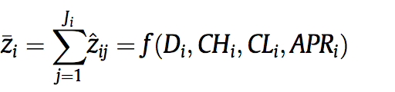
where Di denotes demographic information; CHi denotes credit history; CLi denotes credit limit, APRi denotes the assigned APR. The Bayesian behavior scoring model and the CART-based credit scoring model are combined by the average latent customer quality. After applying the combined model to empirical data, the authors conclude that Bayesian-CART not only has higher classification accuracy, but also reduce the possible high risks associated with errors.
In general, credit scoring is based on 5Cs: the character of the consumer, the capital, the collateral, the capacity and the economic conditions. Character is the customer’s honesty and past reliability in making payments to the bills, which partly indicates if the consumer can pay the bills on time in the future. Capital represents the financial net worth of what the consumer owns, which takes capacity (income) and collateral (property) into account. Conditions refer to the local general economic conditions that may affect the repayment of bills of the consumer.
The financial institutions, such as banks, make decisions about whether or not to grant credit to customers, mainly based on credit scoring system. The banks look at the credit score of the customers and figure out if it is reliable to issue a credit card; if so, the banks decide what is the most reasonable credit to grant so that the customers will have the ability to pay off the whole debt and won’t complain about the credit limit either.

How to Mitigate Credit Risks?
In response to the risk of borrower’s default, financial instruments called credit derivatives were developed. Robert S. Neal, an economist at the Federal Reserve Bank of Kansas City, explained the rationale and use of credit derivatives in 1996. Credit derivatives are financial contracts that provide insurance against credit risk for investors, debt issuers, and banks. It consists of three types: credit swaps, credit options, and credit-linked notes.
Credit swaps allow banks to swap their payments from some of their loans for payments from other institutions because these loan portfolios are highly concentrated on specific industries and geographic areas. The most common credit swap is a total return swap, which allows banks to diversify credit risk while at the same time maintaining confidentiality of customers’ financial records and incurs lower administrative costs.
Credit options, however, provides insurance to hedge the risk of adverse changes in credit quality of financial assets since the loss from the investment will be offset by the gains from the option. For instance, Neal gives an example where the investor that owns $10 million bonds of a company might buy a put option on the bonds with a $9 million strike price for $40,000. The investor can sell the bonds for $9 million, which is guaranteed payment. Or if the market value falls to only $7 million, the investor can still have the payoff of $2 million. If the market value raises to over $9 million, say $12 million, the value of put option will become zero and allows the investor to benefit from bond price increase. Here, the strike price is a predetermined price and the put option refers to the investor’s right to sell stocks or bonds at the predetermined strike price.
Apart from credit swaps and credit options, credit-linked note is also very popular and effective. By combining regular bond and credit option, it promises to make periodic interest payments and a large lump sum payment at the maturity date of the bond and allows the issuer to reduce the note’s payments if necessary as well. Credit card companies usually prefer credit-linked note since it’s a convenient way to reduce risk exposure.
In the paper How Much Do Banks Use Credit Derivatives to Reduce Risk, the authors examine the use of credit derivatives by US bank holding companies from 1999 and 2003 with assets in excess of one billion dollars. According to the Federal Reserve Bank of Chicago Bank Holding Company Database, in 2003, only 19 out of 235 large banks use credit derivatives. This may be due to the potential regulatory issues and risks of credit derivatives, such as, liquidity risks, operational risks and capital requirements for credit derivatives, etc. In reality, financial institutions often use other techniques to manage risks: loan underwriting standards, diversification, and asset securitization.
Loan underwriting standards: They are standards established to restrict the amount of debt that can be issued to a person, the terms of loans, and what interest rates should be charged. In U.S. CFR (code of federal regulations) Title 12 614.4150, it gives specific regulations of lending policies and loan underwriting standards. The code requires each institution to adopt written standards, which provide, at a minimum, some supporting credit and financial information, the minimum standards for loan disbursement, servicing and collections, loan approval delegations and loan pricing practices. This regulation forces both the banks and the borrowers to obey the standards and reduces the exposure to credit risk to some extent.
Diversification: The banks sometimes offer borrowers a portfolio of loans, which combine loans in different sectors and industries. In The Optimal Size of a Bank: Costs and Benefits of Diversification, the authors show that the banks can commit to a higher level of monitoring by diversifying bank portfolios and diversification also increases the banks’ incentives to monitor lenders.
Securitization: According to Investopedia, securitization is the process through which banks combine their financial assets/products into various pools, and then sell this repackaged financial instrument to investors. In this way, the banks transfer the credit risk to the investors. Mortgage backed securities, asset backed securities, and collateralized debt obligations are all different types of securitization. A large number of banks securitized their portfolios to increase their credit card accounts in 20th century. For example, as Charles W. Calomiris and Joseph R. Mason pointed out, Citicorp led the sector by increasing its credit card accounts by 42% in 2 years in early 1990s. To finance the credit card receivables, some banks use off-balance sheet finance or use bank equity and debt; however, securitization reduces adverse-selection costs of financing receivables by isolating credit card accounts and exposing them to the scrutiny of securities purchasers, rating agencies and etc. Securitization not only helps the banks avoid financing receivables through equity capitals, so further decreases the costs of maintaining equity capital, but also helps mitigate regulatory capital requirement by allowing banks to move assets off their balance sheets. Therefore, now the banks are allowed to convert illiquid loans to liquid funds and increase their lending ability.
Each technique has its own benefits and shortcomings. For example, the markets for securitized assets provide valuable tools for managing credit risk; meanwhile, according to Robert S. Neal, this approach is only suited for loans with standardized payment schedules and similar credit risk characteristics, such as home mortgages and automobile loans. For commercial and industrial loans, it’s more promising to use credit derivative. It is important that the financial institutions consider all factors when deciding which strategy to use to mitigate their credit risk.

Part 2: Individual investors vs. Companies/ Governments

Now I have examined the reason why credit risks arise for financial institutions and analyzed how they handle the risks, I want to move on to study how credit risks are formed for individual investors when they hold companies’ or governments’ bonds. In this situation, credit risks emerge when the companies or governments default or even go bankruptcy.

Credit Rating System
According to Wikipedia, credit rating is defined as an evaluation of the credit worthiness of a debtor, especially a business (company) or a government. Similarly to credit scoring, which evaluates individuals’ credit worthiness, credit rating is for companies and businesses. Individuals and entities that purchase the bonds issued by the companies will take credit rating into consideration to make investment decisions. A poor credit rating indicates that it is highly possible that the company will default, according to a credit rating agency’s opinion.
There are a few types of credit ratings: sovereign credit rating, short-term rating, and most commonly, corporate credit rating. And the “Big Three” rating agencies are Moody’s, Standard & Poor’s, and Fitch Ratings. The rating is described in both upper and lower case letters and numbers and varies from the highest level AAA (or Aaa for Moody’s) to the lowest level D (or C for Moody’s). Different agencies might give different ratings for the same company. So how do credit agencies determine a business’ credit rating? A news report on allbusiness.com explained that the information used to create credit rating is gathered from companies that the business has financial relationships with, for example, suppliers, as well as, the business’ public financial reports, business history, and its past history of payment obligations. All the factors are included in the calculations in mathematical or statistical formulas to create credit ratings.
In history, various scholars have applied different models to predict bond ratings of the businesses. In An Alternative Approach to Predicting Corporate Bond Ratings, Richard R. West suggested a more accurate approach based on an earlier study by Lawrence Fisher, in which Fish used three variables to estimate the risk of default: measures of variability of the firm’s earnings; measures showing how reliable the firm has been in meeting its obligations; and measures depending on the firm’s capital structure. First, West obtained the ratings on the bond issues included in the five cross sections. An example is as follows:
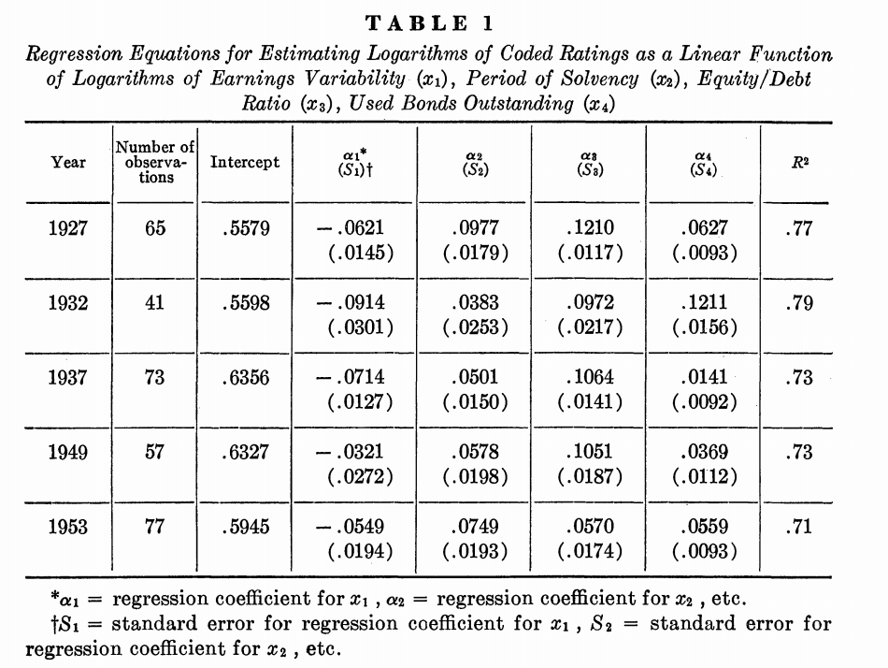
Next, the logarithms of the coded ratings are regressed on the logarithms of the independent variables of earning variability, period of solvency, equity to debt ratio and bonds outstanding. Finally, each bond was assigned a rating comparable to those assigned by Moody’s by placing it in the appropriate estimating interval. The results are presented below:
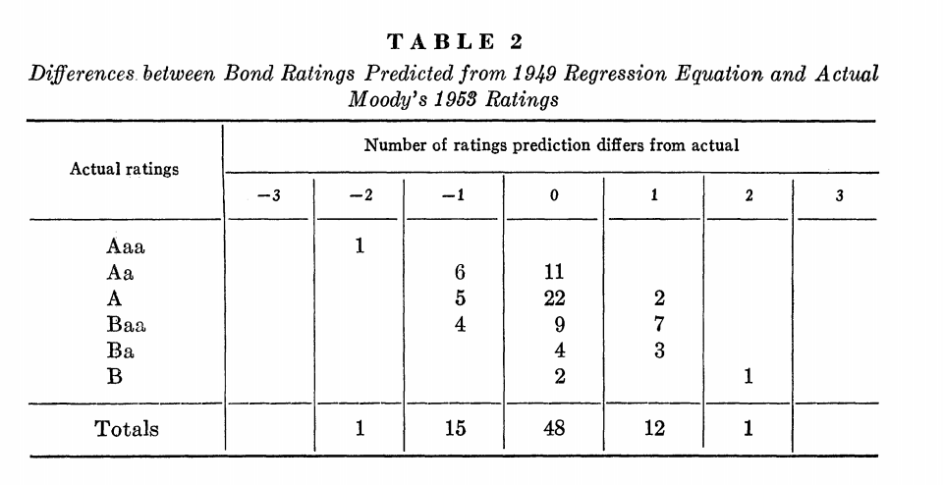
Boot, Milbourn, and Schmeits pointed out that credit ratings serve as coordination mechanisms in their paper published in 2005. Credit ratings can help obtain multiple equilibria by providing a “focal point” for both firms and investors. The ratings not only monitor the companies during the credit watch procedures, but also affect the investors’ investment decisions. Credit rating agencies have regular interactions with firms and engage in implicit contracting with the firm. When agencies observe any potential changes in the firm characteristics, they will notify management and ask for clarification from the firm. The rating is then put “on watch”. The firm will implicitly commit to undertake certain actions to mitigate the adverse consequences of the change and if it manages to live up to this implicit contract, the rating may get reconfirmed. If not, the firm may be downgraded.
Based on companies’ credit ratings, the investors will be able to make informed investment decisions with some assurance and less risk of bankruptcy. Since the rating symbols are easy to understand, investors can make quick decisions and save time and efforts on deep understanding of the companies.

How to Mitigate Credit Risks:
For individual investors, it is also important to consider potential default risk. Therefore, when evaluating corporate or government bonds, the investors should look at credit ratings, as well as some financial ratios, such as, interest coverage ratio and capitalization ratio. In an article on Bondsquawk.com, the interest coverage ratio is introduced as a measure to find out how much money the company generates each year to fund annual debt interest by using EBIT formula; the capitalization ratio, is used to find out how much interest-bearing debt the company can carry in relation to its asset value by calculating the ratio of long-term debt and sum of long-term debt and shareholder’s equity. Bondsquawk.com recommends that the investors also look at the company’s future economic outlook under its environment. All factors that can possible affect the bond market (fixed income securities market) should be taken into consideration.
HSBC Bank, instead, recommends that the investors diversify their investments instead of putting all their eggs into one basket, especially during economic downturns. Bond funds, for instance, are a portfolio of bonds, which could be an option for diversification.
What if the company already goes bankruptcy and fails to pay its debt? Then the investors may use credit default swap (CDS), one of the most widely used tools, to mitigate the default risk. CDS has existed since early 1990s and increased after 2003. According to Deutsche Bank Research paper Credit Default Swaps: Heading towards a more stable system, a (single name) credit default swap allows the contracting partners to trade or hedge the risk that an underlying entity defaults-either a corporate or a sovereign borrower. The protection buyer pays a yearly premium until a pre-defined credit event occurs or until the contract matures. The protection seller, however, assumes the financial loss in case the underlying security defaults or the reference borrower becomes insolvent, as shown in the following graph.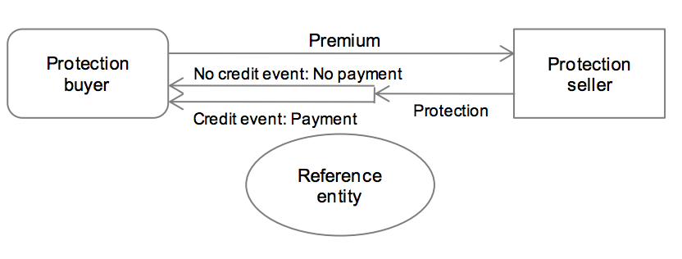

CDSs do not require the protection buyer and seller to adjust the underlying loan portfolios and incur lower costs. Besides being a risk management tool to complement traditional hedging methods, CDSs can also act as a trading instrument to exploit possible mispricing between different asset classes. Moreover, CDS spreads are used more often as a measure of credit risk: the rating agencies use information derived from CDS prices to calculate “market implied ratings”.

Investopedia, credit risk: http://www.investopedia.com/terms/c/creditrisk.asp
Modelling the credit risk for portfolios of consumer loans: Analogies with corporate loan models, Lyn C. Thomas, Quantitative Financial Risk Management Centre, School of Management, University of Southampton
Structural models in consumer credit, Fabio Wendling Muniz de Andrade, Lyn C. Thomas, School of Management, University of Southamton, 2007
A Bayesian latent variable model with classiﬁcation and regression tree approach for behavior and credit scoring, Ling-Jing Kao, Chih-Chou Chiu, Fon-Yu Chiu, National Taipei University of Technology, Taiwan
Credit Derivatives: New Financial Instruments for Controlling Credit Risk, Robert S. Neal, 1996
How Much Do Banks Use Credit Derivatives to Reduce Risk, Bernadette A. Minton, Rene Stulz, and Rohan Williamson, June 2006
CFR 614.4150: http://www.gpo.gov/fdsys/pkg/CFR-2011-title12-vol6/pdf/CFR-2011-title12-vol6-sec614-4150.pdf
The optimal size of a bank: Costs and benefits of diversification, Vittoria Cerasi, Sonja Daltung, September 1998
Definition of Securitization: http://www.investopedia.com/terms/s/securitization.asp
Credit Card Securitization and Regulatory Arbitrage, Charles W. Calomiris, Joseph R. Mason, 2004, Kluwer Academic Publishers
The role of securitization in bank liquidity and funding management, Elena Loutskina, , The Darden School of Business Administration, University of Virginia, 2011
Wikipedia, Credit Rating definition: http://en.wikipedia.org/wiki/Credit_rating
How Credit Agencies Determine A Business’ Credit Rating? http://www.allbusiness.com/business-finance/business-loans-business-credit/11193-1.html
An Alternative Approach to Predicting Corporate Bond Ratings, Richard R. West, Journal of Accounting Research, Spring 1970
Credit Ratings as Coordination Mechanisms, Arnoud W. A. Boot, Tood T. Milbourn, and Anjolein Schmeits, 2005, Oxford University Press
Understanding credit risk for corporate bonds, http://www.bondsquawk.com/2013/01/14/understanding-credit-risk-for-corporate-bonds/
Understanding default risk to better prepare for market changes, https://www.assetmanagement.hsbc.com/hk/attachments/education-centre/eng/bond_essence_6_en.pdf
Credit Default Swaps: Heading towards a more stable system, Christain Weistroffer, December 21, 2009, http://www.dbresearch.eu/PROD/DBR_INTERNET_DE-PROD/PROD0000000000252032.PDF

