Quantitative Investment Research Based on Merrill Lynch Investment cycle
Introduction: Merrill Lynch’s investment clock model provides us a framework of asset allocation based on the economic cycle. It divides the economic cycles to four phases and has different asset management strategies for each phase (More details in the following diagrams). In this research I want to estimate the potential returns by predicting economic cycles and adjusting portfolios consisting of cash, bond, stock and real estate in time based on the model.

Step 1: Collect the historical data for many economic indictors such as Money Supply, Consumer Sentiment, Producer Price Index.

Step 2: Select the leading indicators and develop an algorithm to use these indicators to predict the economic cycle (Key step). And run a back test to verify that it works

Step 3: Manage the portfolio and hedge the position according to Merrill Lynch investment clock model. For example, in the Boom phase when stock prices are very high, I short sale the stock and keep the cash for the incoming slowdown phase.

Step 4: Estimate the returns based on the back test.

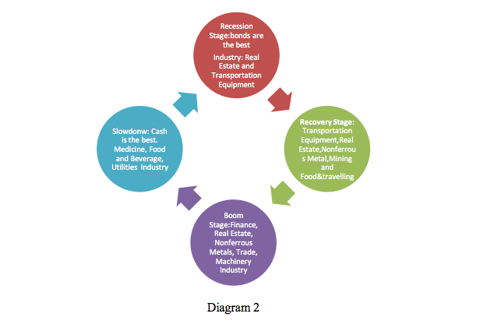
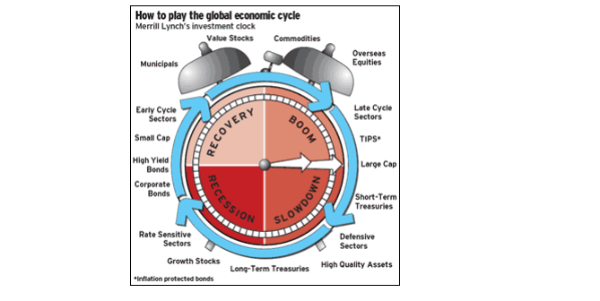

In the real economy and capital markets, there is a fact of obvious industry rotation and investment clock. The Investment Clock model splits the economic cycle into four phases depending on the direction of growth relative to trend and the direction of inflation. In this

Currency recovery phase (Recession): in this stage bonds are the best choice, as for the industry allocation, the real estate and transportation equipment are the best choice which are rate sensitive and growth stocks sectors.

Economy recovery phase (Recovery): in this stage as for the industry allocation we believe that the delivery equipment, real estate, nonferrous metal, mining, and food travel are the best choice; normally early cycle sectors and small-cap are mostly recommended in this stage.

Overheating stage (Boom): the Housing real estate, nonferrous metals, trade, machinery and other industries are the best option, this phase belongs to the heaven of mid-stream sector and large-cap & late cycle sectors

Final stage (stagflation): Cash is the best option. No industry can get absolute
return. Relatively the defective industry like medicine, food and beverage, utilitiescould be considered. Currently in China A-share looks more likely in this stage.

